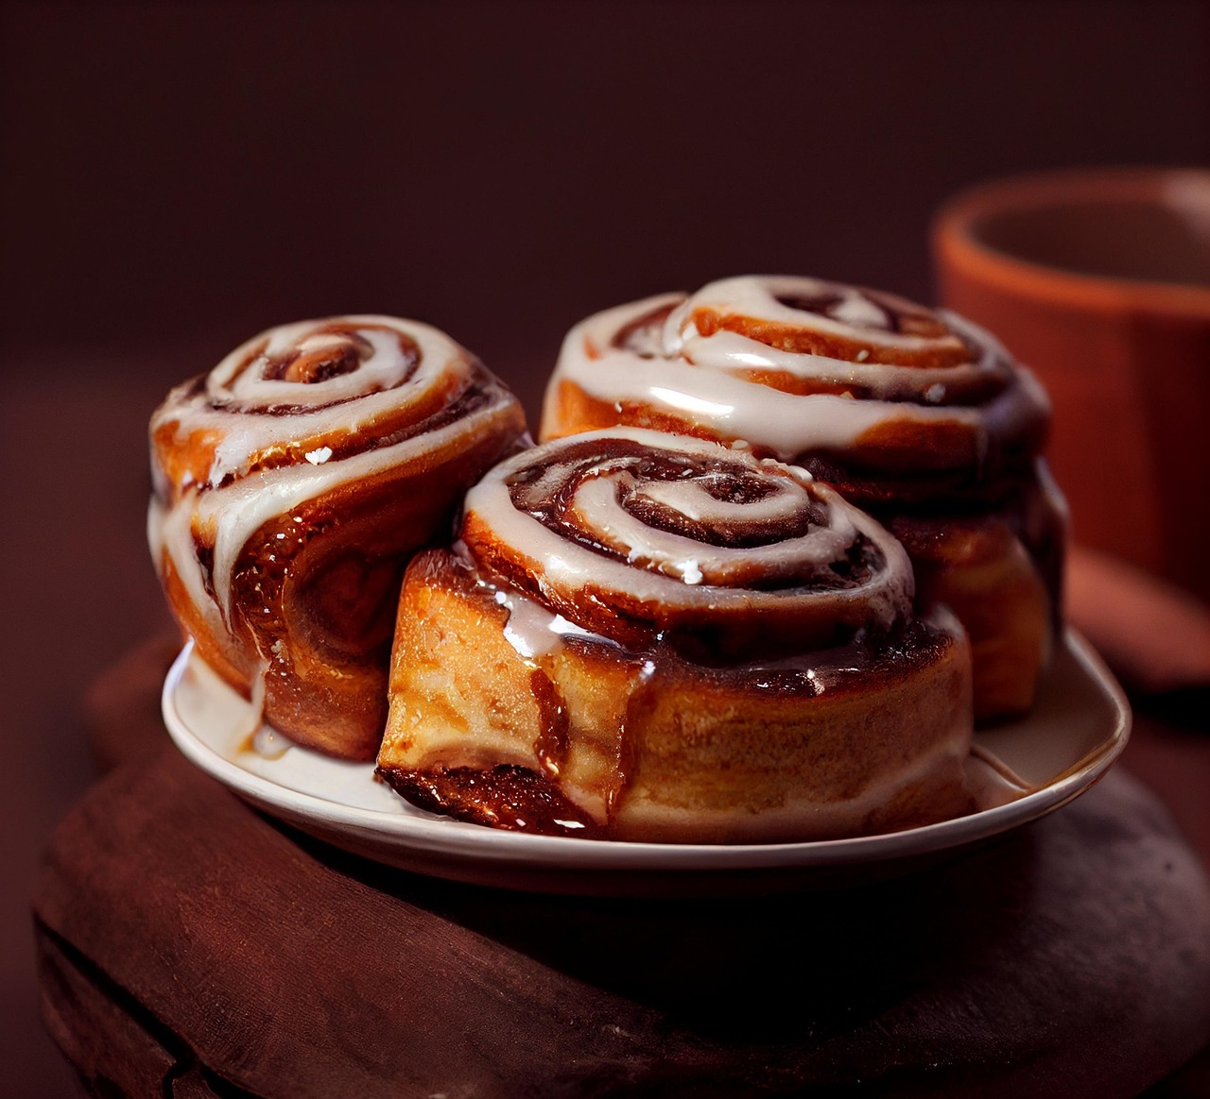

By: Meerab Hanif (01-134251-041) Iqra Agha (01-134251-026)

Subject: Information Communication and Technology

Submitted to: Sir Umer Khattak

**Online Bakery**

**ICT Project report**

# Abstract

This project involves designing and developing a responsive and interactive website for an online bakery, “CakeBakery” using HTML, CSS. The website serves as a platform for showcasing bakery products, allowing users to browse menus, add items to a cart, and place orders. This project aims to bridge the gap between traditional bakery businesses and the digital world by offering a user friendly and visually appealing interface.

# Objective

* To design a user-friendly website interface for an online bakery.
* To implement product browsing and order features.
* To integrate responsive design for mobile and desktop users.
* To enhance customer engagement through attractive UI/UX.
* To provide a simplified order placement experience.

# Introduction

The rapid evolution of web technologies has enabled businesses to go digital and expand their customer base. This project utilizes HTML for structure, CSS for styling. The website features a home page, product listing menu and contact page. It demonstrates how modern web technologies can support traditional businesses by providing greater visibility and customer interaction.

# Features of our Bakery

**Aesthetic and Responsive Design**

* Clean layout with pastel color tones (light pink and white).
* Mobile- and desktop-responsive design.
* Attractive fonts and image-rich sections.

**Intuitive Navigation**

* A fixed header with navigation links: Home, Our Cakes, Menu, About Us, Shop, and Contact Us.
* Smooth scrolling and hover effects for better interactivity.

**Product Showcasing**

* Highlighted featured cakes with names, images, and prices.
* Multiple categories like Cakes, Cupcakes, and Donuts.

**Interactive Buttons**

* "Add to Cart" and "Confirm Order" buttons with animation.
* "Start Shopping Now" button for direct access to shop.

**Order Placement Support**

* Fields to input delivery address.
* Cart summary and clear checkout experience.

**Contact and Support**

* Email and phone support details in the footer section.
* "Contact Us" section for assistance.

# Tools and Technologies

* Languages: HTML, CSS
* Visual studio code
* Google chrome (Browser for testing)
* Online image resources (for cupcake/cake thumbnails)
* Fonts: Google Fonts (Playfair Display, Open Sans)

# Challenges Faced

* Aligning design responsiveness across different screen sizes.
* Ensuring user input validation for address field.
* Managing image optimization without compromising load time.

# Learning Outcomes

* Gained practical experience in HTML structuring and semantic layout.
* Mastered CSS for layout, hover effects, and responsive design.
* Developed skills in organizing a web development project from scratch.

Code snippets

<!DOCTYPE html>

<html lang="en">

<head>

  <meta charset="UTF-8" />

  <meta name="viewport" content="width=device-width, initial-scale=1.0"/>

  <title>CakeBakery</title>

  <style>

    body {

      margin: 0;

      font-family: 'Open Sans', sans-serif;

      background: #fff;

    }

    /* Top Bar */

    .top-bar {

      background: #f8a9b6;

      color: white;

      padding: 10px 30px;

      font-size: 14px;

      display: flex;

      justify-content: space-between;

      align-items: center;

    }

    /* Header */

    header {

      background: white;

      padding: 20px 30px;

      display: flex;

      justify-content: space-between;

      align-items: center;

      border-bottom: 5px dotted #f8a9b6;

    }

    .logo {

      font-family: 'Playfair Display', serif;

      font-size: 28px;

      color: #333;

    }

    nav {

      display: flex;

      gap: 30px;

      align-items: center;

    }

    nav a {

      text-decoration: none;

      color: #f8a9b6;

      font-weight: 600;

      transition: color 0.3s ease, transform 0.3s ease;

    }

    nav a:hover {

      color: #64c3c2;

      transform: translateY(-3px);

    }

    /* Hero Section */

    .hero {

      background-image: url('cinnamon-rolls.jpg');

      background-size: cover;

      background-position: center;

      padding: 150px 30px;

      color: white;

      text-align: left;

      transition: all 0.5s ease-in-out;

    }

    .hero h1 {

      font-family: 'Playfair Display', serif;

      font-size: 48px;

      line-height: 1.2;

      margin-bottom: 20px;

      color: #fff;

    }

    .hero p {

      font-size: 18px;

      color: white;

      margin-bottom: 30px;

    }

    .button {

      background-color: white;

      color: black;

      padding: 10px 25px;

      border-radius: 25px;

      text-decoration: none;

      font-weight: bold;

      transition: all 0.3s ease-in-out;

    }

    .button:hover {

      background-color: #f8a9b6;

      color: white;

      transform: scale(1.05);

    }

    /* Featured Cakes */

    .featured {

      text-align: center;

      padding: 60px 30px;

    }

    .featured h2 {

      font-family: 'Playfair Display', serif;

      font-size: 32px;

      color: grey;

      margin-bottom: 10px;

    }

    .featured p {

      color: grey;

      margin-bottom: 40px;

    }

    .cakes {

      display: flex;

      justify-content: center;

      gap: 30px;

      flex-wrap: wrap;

    }

    .cake {

      width: 220px;

      background: white;

      border-radius: 12px;

      box-shadow: 0 4px 12px rgba(0, 0, 0, 0.1);

      overflow: hidden;

      transition: transform 0.3s ease, box-shadow 0.3s ease;

    }

    .cake:hover {

      transform: translateY(-5px);

      box-shadow: 0 6px 18px rgba(0, 0, 0, 0.15);

    }

    .cake img {

      width: 100%;

      height: 150px;

      object-fit: cover;

    }

    .cake p {

      margin: 10px;

      font-weight: bold;

      color: #f8a9b6;

    }

    .cake h4 {

      margin: 5px;

      color: black;

    }

    /* Sections */

    section {

      padding: 60px 30px;

    }

    section h2 {

      font-family: 'Playfair Display', serif;

      font-size: 32px;

      color: #f8a9b6;

      margin-bottom: 15px;

      text-align: center;

    }

    section p {

      color: #555;

      font-size: 18px;

      line-height: 1.5;

      text-align: center;

      max-width: 700px;

      margin: 0 auto 30px;

    }

    section li {

      text-align: center;

      color: #344;

      font-size: 16px;

      list-style: none;

      margin-bottom: 10px;

    }

    h1 {

      text-align: center;

      color: #344;

      margin-top: 20px;

    }

    /* Footer */

    .footer {

      background-color: #f8a9b6;

      padding: 40px 30px;

    }

    .footer p {

      text-align: center;

      color: white;

      font-size: 16px;

      line-height: 1.6;

    }

    #menu {

  padding: 60px 30px;

  background: #fff9f9;

}

.menu-category {

  margin-top: 40px;

}

.menu-category h3 {

  color: #f8a9b6;

  font-size: 26px;

  margin-bottom: 20px;

  font-family: 'Playfair Display', serif;

  text-align: center;

}

.menu-grid {

  display: grid;

  gap: 20px;

  max-width: 900px;

  margin: 0 auto;

}

.menu-item {

  background-color: #fff;

  border: 1px solid #f8a9b6;

  border-radius: 12px;

  padding: 15px 20px;

  display: flex;

  justify-content: space-between;

  font-size: 18px;

  color: #344;

  box-shadow: 0 4px 10px rgba(0,0,0,0.05);

  transition: transform 0.3s ease, box-shadow 0.3s ease;

}

.menu-item:hover {

  transform: translateY(-5px);

  box-shadow: 0 8px 20px rgba(0,0,0,0.1);

}

.menu-item span:first-child {

  font-weight: 600;

}

.menu-item span:last-child {

  color: #f8a9b6;

  font-weight: bold;

}

.add-to-cart {

  background-color: #f8a9b6;

  color: white;

  border: none;

  padding: 5px 12px;

  border-radius: 20px;

  cursor: pointer;

  font-size: 14px;

  transition: background-color 0.3s ease;

}

.add-to-cart:hover {

  background-color: #64c3c2;

}

  </style>

</head>

<body>

  <div class="top-bar">

    <span>📞 +92 1234567</span>

    <span>📧 info@cakebakery.com</span>

  </div>

  <header>

    <div class="logo">CakeBakery</div>

    <nav>

      <a href="#home">Home</a>

      <a href="#cakes">Our Cakes</a>

      <a href="#menu">Menu</a>

      <a href="#about">About Us</a>

      <a href="#shop">Shop</a>

      <a href="#contact">Contact Us</a>

    </nav>

  </header>

  <section class="hero" id="home">

    <h1>Quality Products ...<br> with sweet, eggs & breads</h1>

    <p>No one eats something bitter or bland just for the taste — they only do it when they know it'll lead to something delicious in the end.</p>

    <a href="#" class="button">See the recipe</a>

  </section>

  <section class="featured" id="cakes">

    <h2>Our Featured Cakes</h2>

    <p>Made with magic</p>

    <div class="cakes">

      <div class="cake">

        <a href="Strawberry-Cupcakes-Feature.html">

          <img src="Strawberry-Cupcakes-Feature.jpg" alt="Strawberry Cupcake"></a>

        <p>500 Rs</p>

        <h4>Strawberry Cupcakes</h4>

      </div>

      <div class="cake">

        <a href="keylime.html">

          <img src="keylime.jpg" alt="Key Lime Cupcake"></a>

        <p>550 Rs</p>

        <h4>Key Lime Cupcakes</h4>

      </div>

      <div class="cake">

        <a href="amaretto.html">

          <img src="amaretto.jpg" alt="Amaretto Cupcake"></a>

        <p>550 Rs</p>

        <h4>Amaretto Cupcakes</h4>

      </div>

      <div class="cake">

        <a href="coffee.html">

          <img src="coffee.webp" alt="Coffee Cupcake"></a>

        <p>550 Rs</p>

        <h4>Coffee Cupcakes</h4>

      </div>

    </div>

  </section>

  <section id="menu">

  <h2>Menu</h2>

  <p>Check out our delightful dessert options, cakes, and donuts.</p>

  <div class="menu-category">

    <h3>Cakes</h3>

    <div class="menu-grid">

      <div class="menu-item"><span>Black Forest Cake</span><span>3000 Rs</span><button class="add-to-cart" >Add to Cart</button></div>

      <div class="menu-item"><span>Cheese Cake</span><span>3500 Rs</span><button class="add-to-cart" >Add to Cart</button></div>

      <div class="menu-item"><span>Rainbow Cake</span><span>2000 Rs</span><button class="add-to-cart" > Add to Cart</button></div>

      <div class="menu-item"><span>Red Velvet Cake</span><span>2500 Rs</span><button class="add-to-cart" >Add to Cart</button></div>

      <div class="menu-item"><span>Fruit Cake</span><span>1500 Rs</span><button class="add-to-cart" >Add to Cart</button></div>

        <div class="menu-item"><span>Mocha Cake</span><span>2500 Rs</span><button class="add-to-cart" >Add to Cart</button></div>

    </div>

  </div>

  <div class="menu-category">

    <h3>Cupcakes</h3>

    <div class="menu-grid">

      <div class="menu-item"><span>Matcha Cupcake</span><span>660 Rs</span><button class="add-to-cart" >Add to Cart</button></div>

      <div class="menu-item"><span>Strawberry Cupcake</span><span>660 Rs</span><button class="add-to-cart" >Add to Cart</button></div>

      <div class="menu-item"><span>Vanilla Cupcake</span><span>660 Rs</span><button class="add-to-cart">Add to Cart</button></div>

      <div class="menu-item"><span>Amaretto Cupcake</span><span>660 Rs</span><button class="add-to-cart">Add to Cart</button></div>

      <div class="menu-item"><span>Keylime Cupcake</span><span>660 Rs</span><button class="add-to-cart">Add to Cart</button></div>

    </div>

  </div>

  <div class="menu-category">

    <h3>Donuts</h3>

    <div class="menu-grid">

      <div class="menu-item"><span>Chocolate Sprinkles</span><span>900 Rs</span><button class="add-to-cart">Add to Cart</button></div>

      <div class="menu-item"><span>Glazed Donuts</span><span>900 Rs</span><button class="add-to-cart">Add to Cart</button></div>

      <div class="menu-item"><span>Strawberry Jelly Donut</span><span>900 Rs</span><button class="add-to-cart">Add to Cart</button></div>

      <div class="menu-item"><span>UBE Donut</span><span>900 Rs</span><button class="add-to-cart">Add to Cart</button></div>

      <div class="menu-item"><span>Coconut Donut</span><span>900 Rs</span><button class="add-to-cart" >Add to Cart</button></div>

       <div class="menu-item"><span>Wonut</span><span>900 Rs</span><button class="add-to-cart">Add to Cart</button></div>

    </div>

  </div>

</section>

<div style="text-align:center; margin-top: 30px;">

  <button class="button">View Cart</button>

</div>

  <section id="about">

    <h2>About Us</h2>

    <p>At CakeBakery, we believe every celebration deserves a sweet touch. From classic cupcakes and dreamy layered cakes to custom treats crafted with love, our mission is simple: bake fresh, bake happy.</p>

  </section>

  <section id="shop">

    <h2>Shop</h2>

    <p>Order your favorite cakes online and enjoy the sweetness at home!</p>

    <li><strong>Fresh Daily:</strong> Baked fresh each morning.</li>

    <li><strong>Customization:</strong> Add personal touches to your order.</li>

    <li><strong>Secure Checkout:</strong> Multiple payment options.</li>

    <li><strong>Fast Delivery:</strong> Within 24 hours.</li>

    <li><strong>Pickup Available:</strong> Choose your convenient time.</li>

    <p><a href="#" class="button">Start Shopping Now</a></p>

  </section>

  <div class="footer">

    <section id="contact">

      <h2>Contact Us</h2>

      <p>Email: info@cakebakery.com<br>Phone: +92 1234567, +92 13578024, +92 99999999</p>

    </section>

  </div>

</body>

</html>

# Website

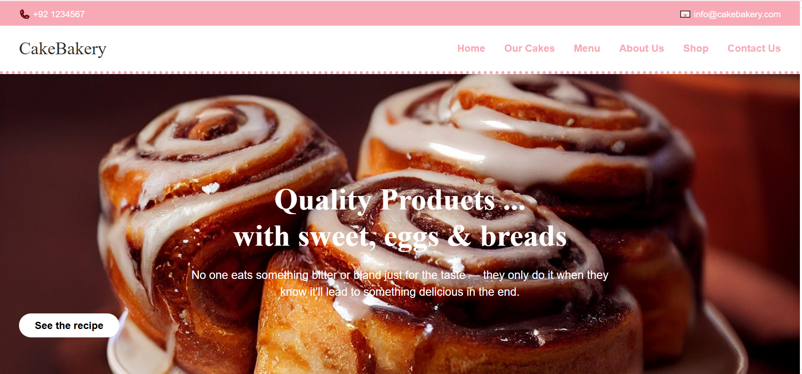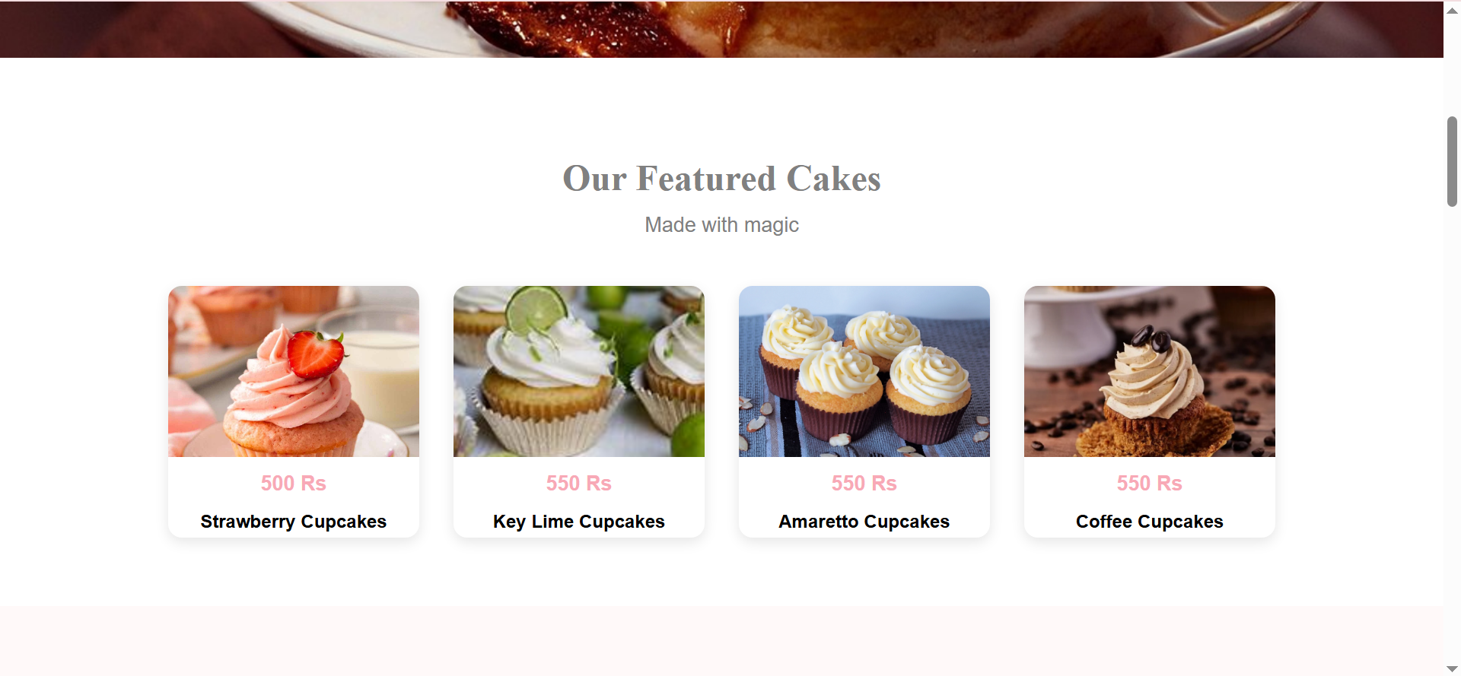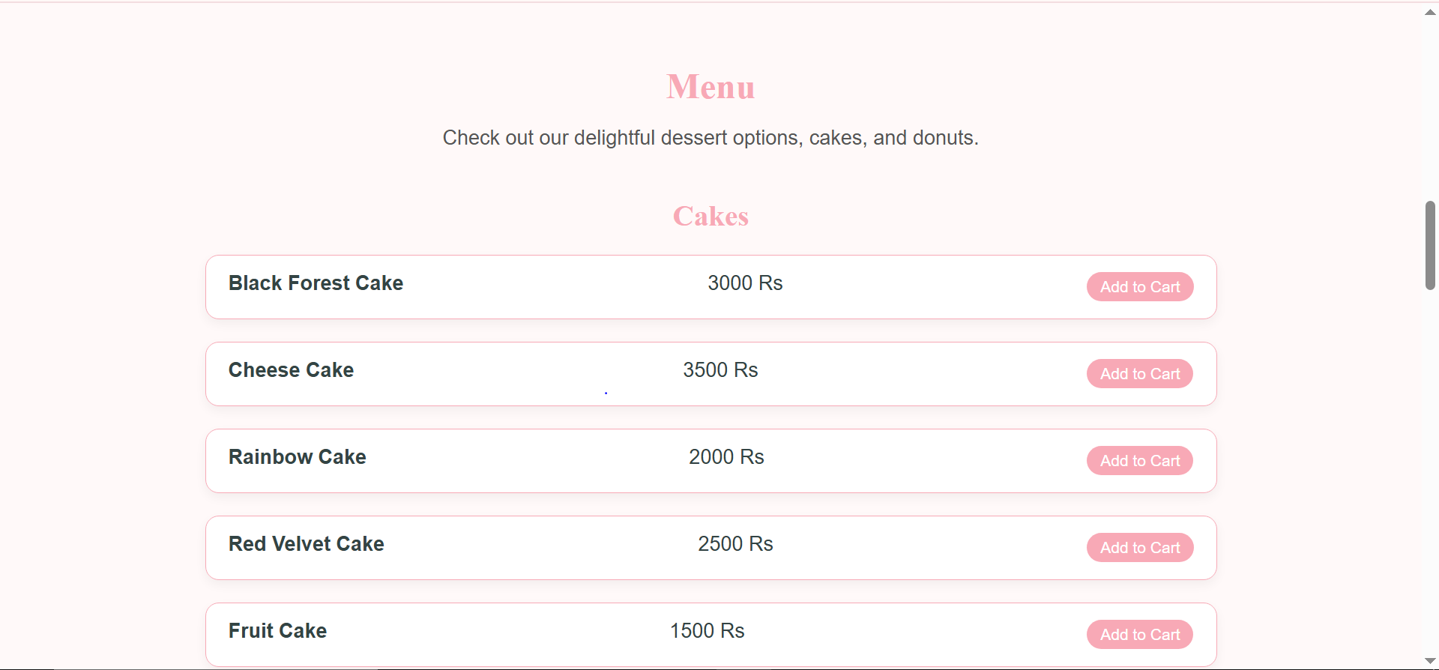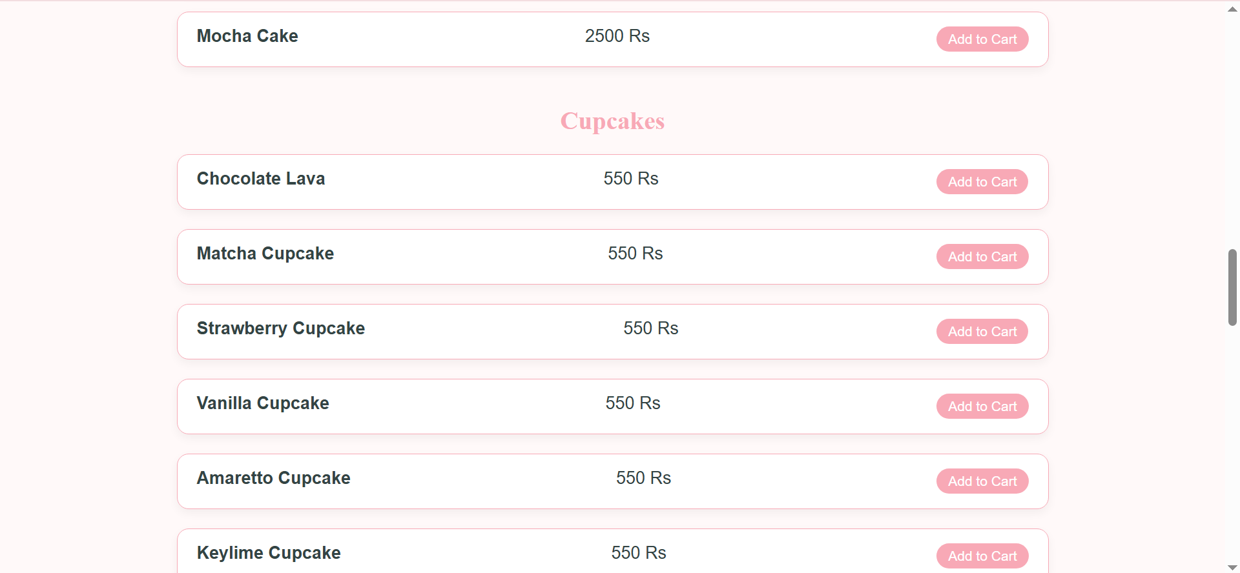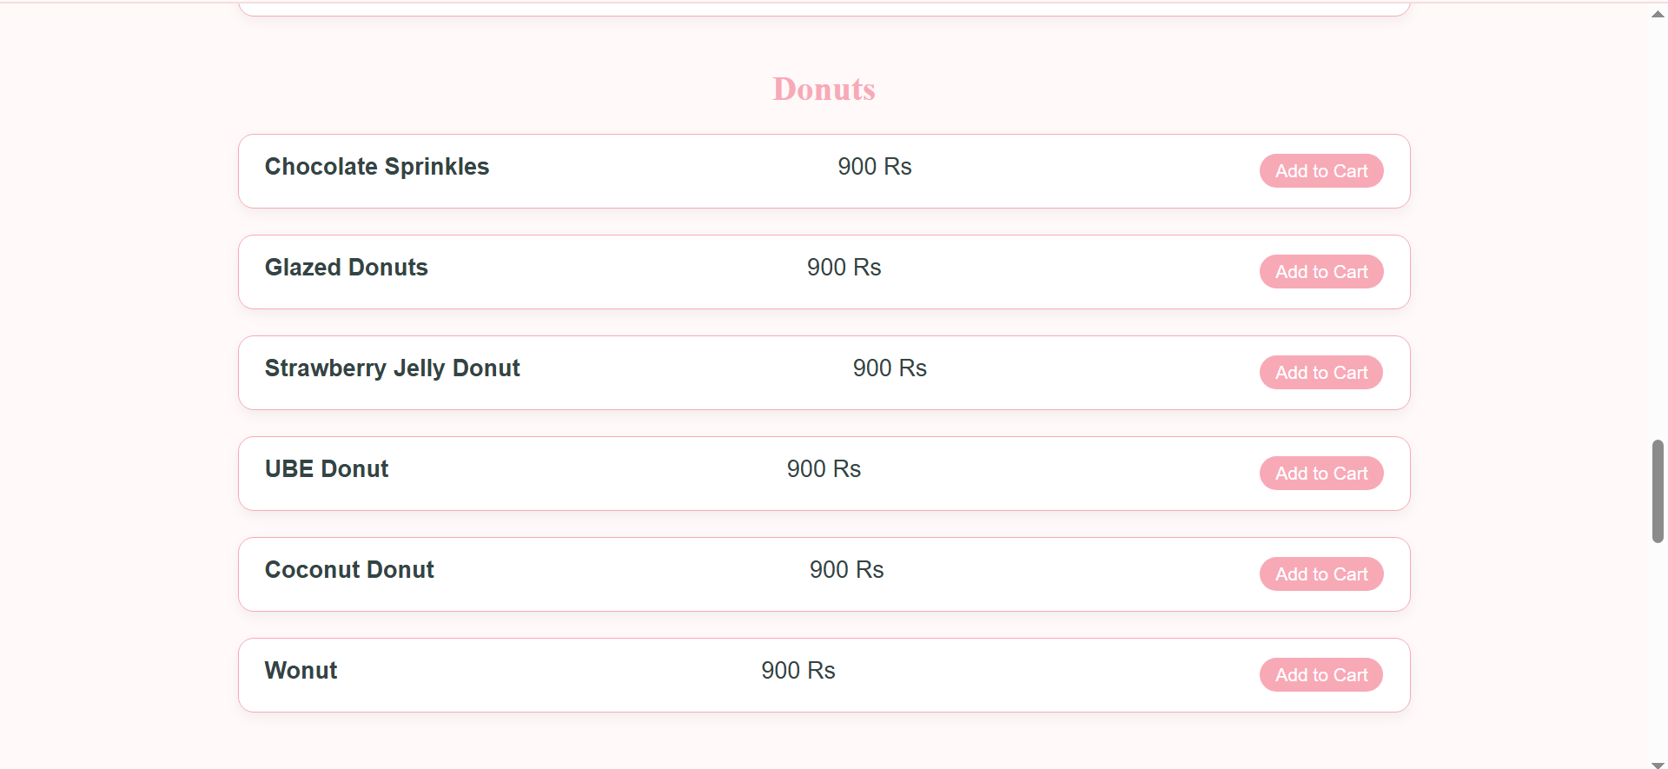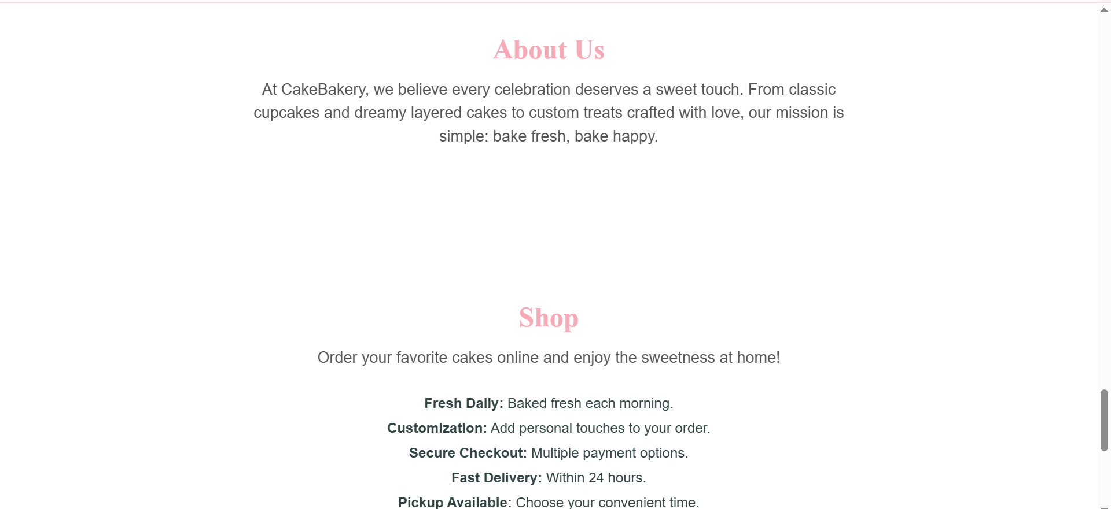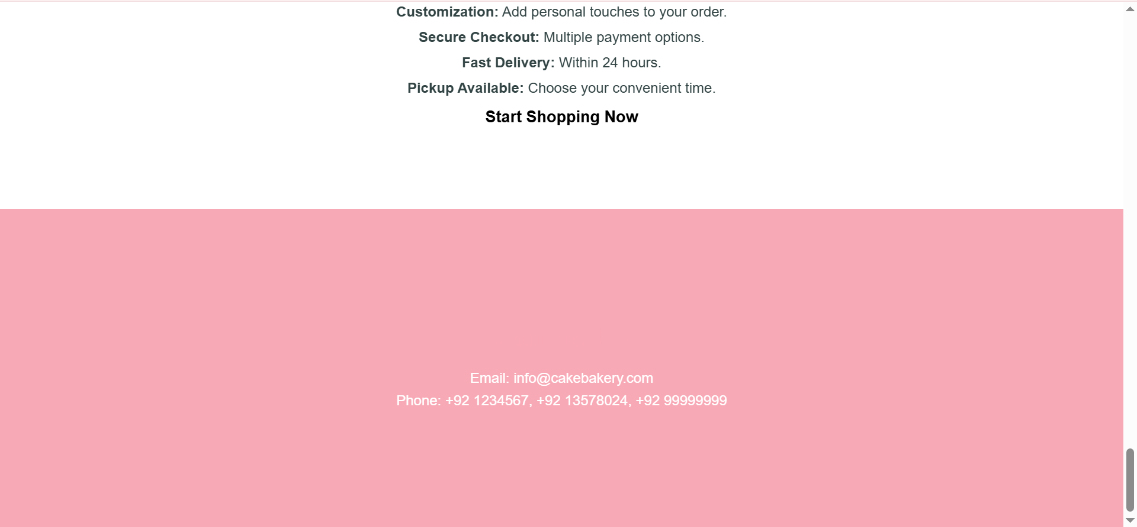

# GitHub Link

# Conclusion

The online bakery project successfully demonstrates the use of core web development technologies to build a dynamic, appealing, and functional website. By integrating design, logic, and interaction, this project not only enhances business accessibility but also provides users with a delightful experience. It reflects how traditional services can benefit from digital transformation.